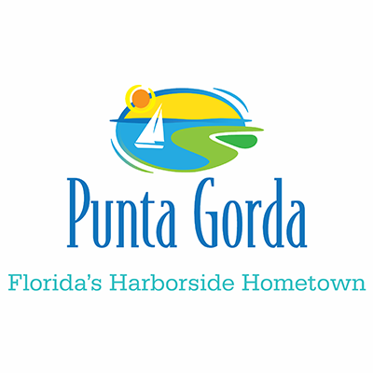

FOR IMMEDIATE RELEASE CONTACT: Linda Sposito
941-575-5060

MEDIA ADVISORY

Beginning the week of Monday, Dec. 2, 2019 through Friday, Dec. 20, 2019 (weather and equipment operations permitting) milling and pavement resurfacing is scheduled on the following streets:

Aruba Ct. from Ryan Blvd. to the cul-de-sac
Padre Island Dr. from Carmichael Dr. to the cul-de-sac
Roseau Dr. from Deborah Dr. to the cul-de-sac
Caya Largo Ct. from Deborah Dr. to the cul-de-sac
St. Croix Ct. from Deborah Dr. to the cul-de-sac
Curacao Ct. from Deborah Dr. to the cul-de-sac
Deborah Dr. from Bal Harbor to the cul-de-sac
Wyatt Circle from Deborah Dr. to the cul-de-sac
Charlotte Amalie from Deborah Dr. to the cul-de-sac
St. David’s Island Ct. from cul-de-sac to cul-de-sac
Paul Place from Deborah Dr. to the cul-de-sac
Bonaire Ct. from Ryan Boulevard to the cul-de-sac
Socorro Dr. from Aqui Esta to the cul-de-sac

Each street will be open to local traffic only. Detours and impact to traffic are to be anticipated. Hours of operation will be between 7 a.m. and 5 p.m.

When driving in the area, motorists are encouraged to drive with extreme caution and be alert for workers in the right-of-ways.

For additional information on this project, please contact Linda Sposito, Sr. Project Manager, City of Punta Gorda Public Works Department at (941) 575-5060 between the business hours of 8:00 a.m. – 4:30 p.m., Monday thru Friday.

